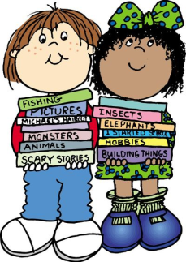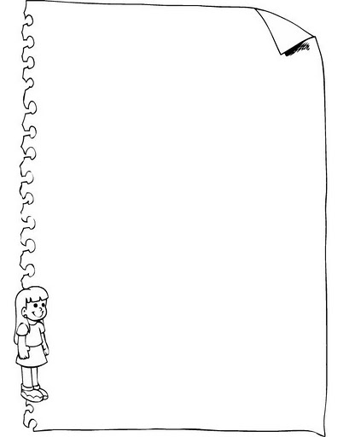

**HAVE GOT / HAS GOT**

Sam ___________ a Granny.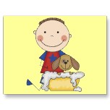

They __________ a ball.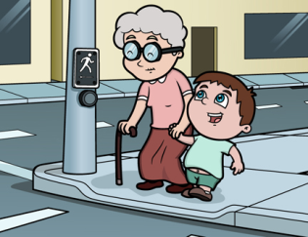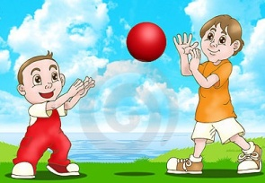

Jessica __________ a flower. 

We _________ books.

Kate __________ a kitten.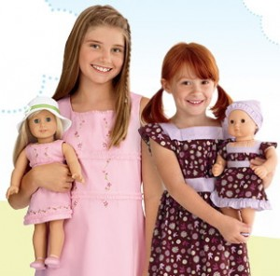

Nick ____________ a dog.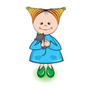

They ___________ dolls.