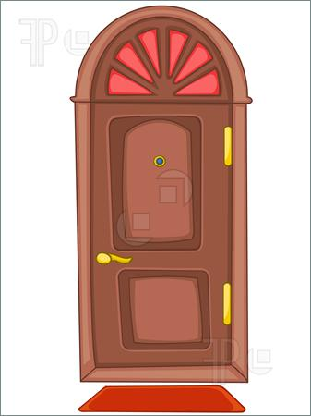 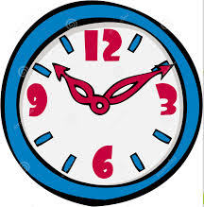 

**d r o o l c o k c h c i r a**

**_______________ _______________ _______________**

 ** **

**o c m u p t r e n d i o w w k o c o b s a e**

**_______________ _______________ _______________**

 

**o r d a b s k e d**

**_______________ _______________**