TELLING THE TIME
Help Tweety color the clocks.
Βοηθήστε τον Τουίτι να χρωματίσει τα ρολόγια.

- Seven o’clock is red. 6. Four o’clock is orange.
- Five o’clock is yellow. 7. Two o’clock is green.
- Ten o’clock is pink. 8. Nine o’clock is brown.
- Eight o’clock is blue. 9. Six o’clock is yellow.
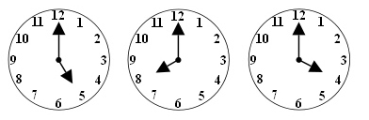
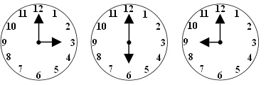
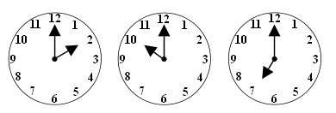
- Three o’clock is purple.

