Have got or Has got?
Συμπληρώστε τα κενά με have got ή has got
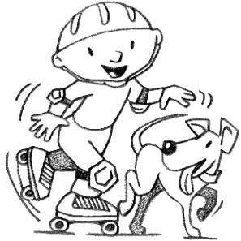

- Jack ___________________ a dog.
- I ___________________ toys.
- Jessica ___________________ a Granny.
- We ___________________ many books.
- Julia ___________________ a bear.
- They ___________________ a kitten.
- John ___________________ an umbrella.
- We ___________________ a house.
- Nick and Mary _______________ a dog.
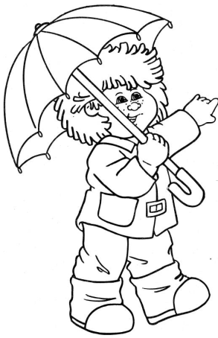
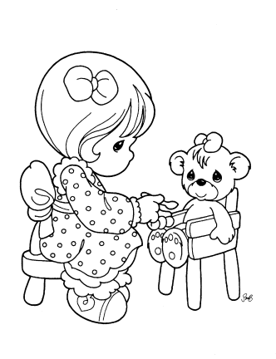
- My brother_________________ a bike.
